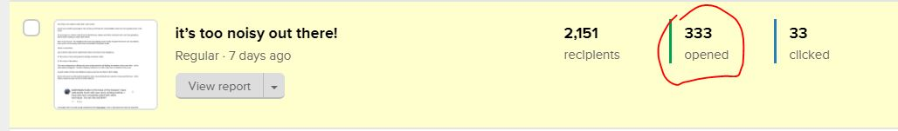

333 humans opened this email: https://preview.mailerlite.com/w1p1g1

------------------------------------------------------------------------------------------

Headline: it’s too noisy out there!
———————————————-------------------------

One thing I can’t stand is noise that I can’t control.

And If you’ve lived long enough in this country you’ll know the uncontrollable noises are 10x anywhere else in the world.

On your way out - there’s noise from the danfo buses, okada, and other road users who can’t stop gossiping about what’s trending or about their friends.

Even in your house - the neighbors that won’t stop playing music loudly, the gate that has its own soundtrack, even worse, the annoying noise those uncatchable mosquitoes make.

Noise is everywhere.

Out of all the noises we’ve experienced, there’s one that is more dangerous.

It’s the enemy of any young person starting a business online.

It’s the noise of abundance.

Too many entrepreneurs offering the same products/service all fighting for attention at the same time - at the same place (instagram) - hereby confusing customers on: who to buy from or whether to buy at all.

A good number of them are defeated or give up and are sent back to their village.

But for the rest of us who break through the noise, by providing these customers noise-proof-devices - which makes customers seek us first for their problems.

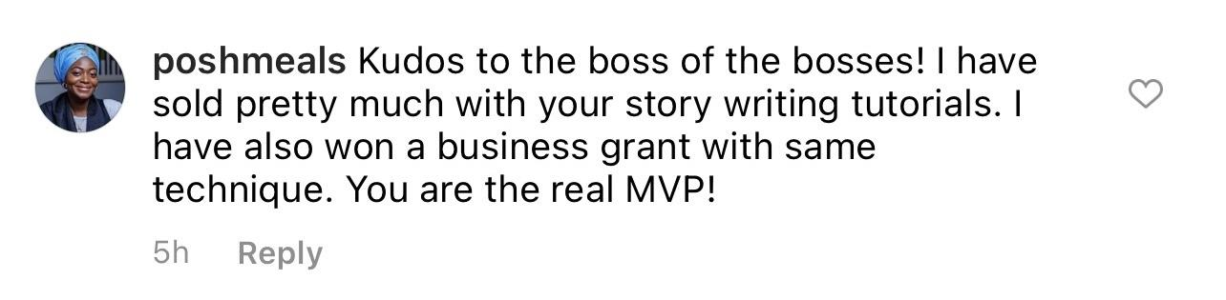

I’ve taught north of 12,000 young entrepreneurs like Posh Meals - how to stay above the noise by using their voice to create the change they seek in their business and personal lives.

That’s why I’ve vowed to do this as often as we have mother’s day in a year - until each and everyone of us can tell stories that’ll make customers choose us - instead of family members that keep selling them bad products.

You should join the Story Writing Bootcamp - this way, you get the rare opportunity to tell stories your customers can’t wait to always hear.

Registration closes today (thursday).

Click this link and join other entrepreneurs to tell stories that’ll make customers excited to buy

------------------------------------------------------------------------------------------------------------------------------

